Quiz 2 BLOCKCHAIN
Q1.
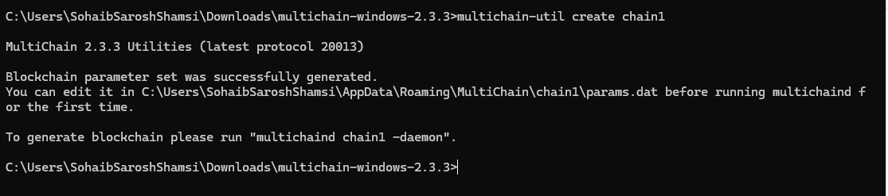
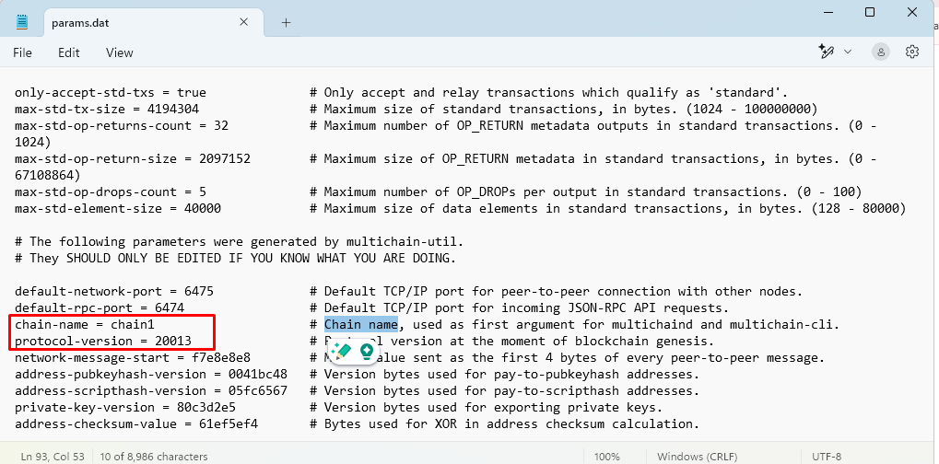
The chain-name is a unique identifier for the blockchain, ensuring that each blockchain instance is distinct. The protocol-version specifies the version of the MultiChain protocol being used, determining the features and capabilities of the blockchain. The network-port and rpc-port are essential for communication between nodes and for interacting with the blockchain remotely, respectively. Lastly, the consensus mechanism dictates whether the blockchain is permissioned (with restricted access) or open (allowing any participant), influencing its security and governance model.

Q2.
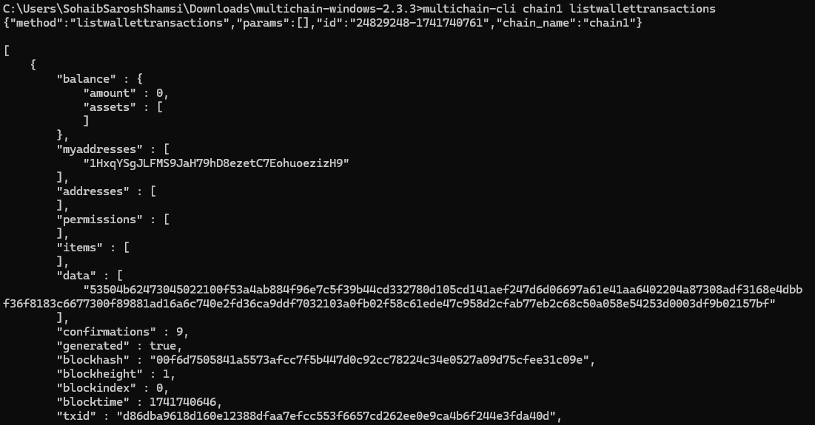
• xid: This is the unique transaction ID assigned to each transaction. It serves as an identifier to track and refer to a specific transaction on the blockchain.
• amount: This indicates the amount of asset transferred in the transaction. A positive value means assets were received, while a negative value means assets were sent.
• confirmations: This represents the number of times the transaction has been confirmed by new blocks. More confirmations generally indicate that the transaction is more secure and irreversible.
• blockhash: The hash of the block that contains the transaction. This is used to verify the block's identity and links the transaction to the blockchain's structure.
• timereceived: The timestamp indicating when the transaction was received by the network. This helps determine the exact time the transaction was processed.

Q3.
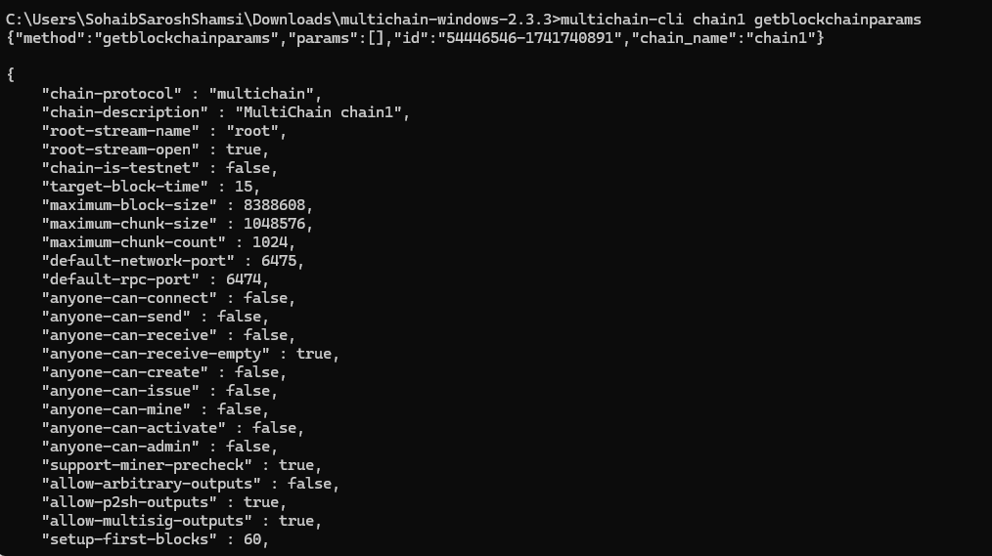
• chain-protocol: Specifies the blockchain protocol, such as bitcoin or multichain. It defines the architecture and rules for transactions.
• mining-diversity: Determines how many entities can participate in mining. It ensures decentralization and network security.
• maximum-block-size: Sets the maximum size for each block, impacting the number of transactions per block and network performance.
• permission-model: Defines access control, indicating if the blockchain is open or restricted (permissioned), affecting who can participate in the network.

Q4.
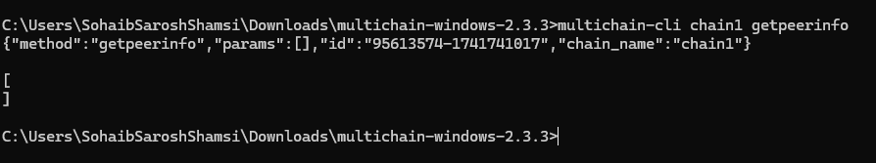
• id: Unique identifier for each peer.
• addr: IP address of the connected peer.
• subver: Version of MultiChain software used by the peer.
• pingtime: Latency between your node and the connected peer, indicating network responsiveness.

Q5.
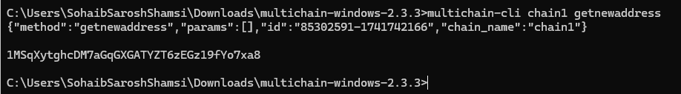
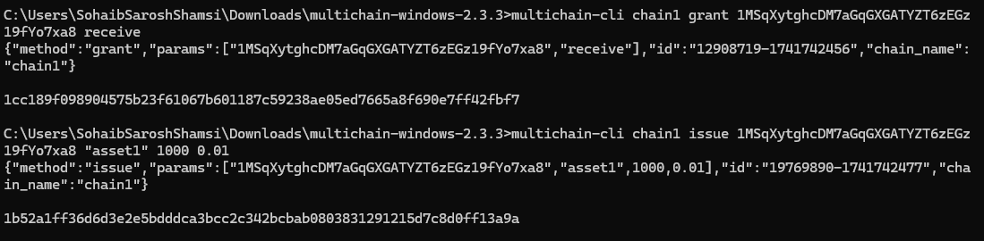
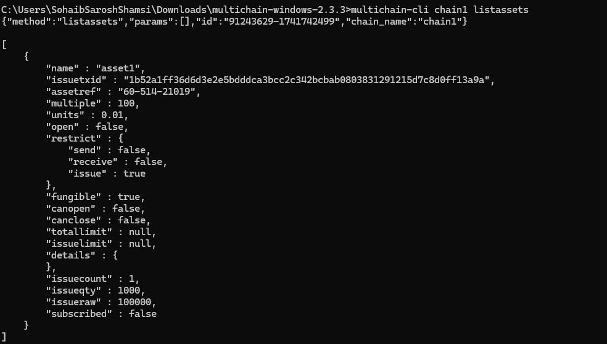
Q6.
Finding txid using: multichain-cli chain1 listwallettransactions
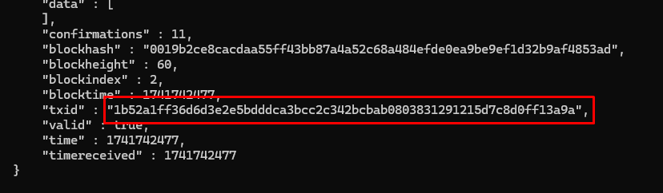
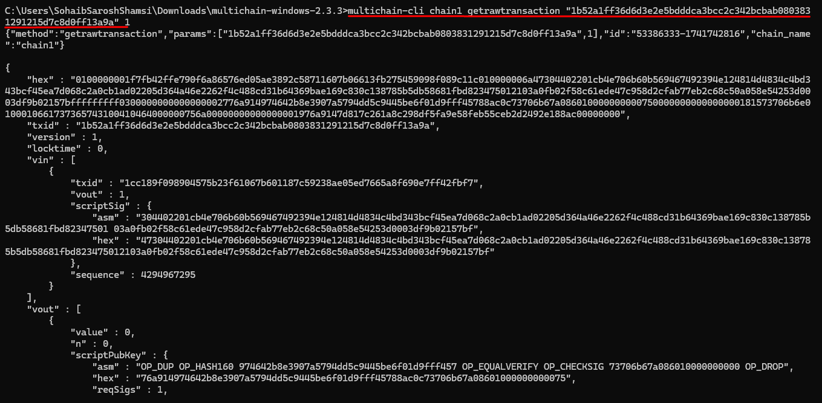
• hex: Provides the transaction in hexadecimal form for low-level inspection or further processing.
• blockhash: Helps identify the exact block in the blockchain where the transaction was confirmed.
• vin: Details which previous transaction outputs are being spent in the current transaction.
• vout: Shows where the assets from the inputs are being sent, including the specific asset types and amounts.

Q7.
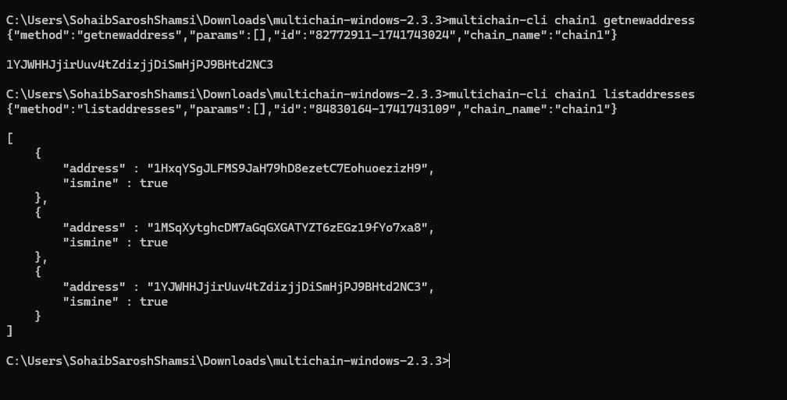
• address: The newly generated address.
• ismine: true, indicating that the wallet owns the address.
• account: Empty, indicating it is the default account.
Q8.
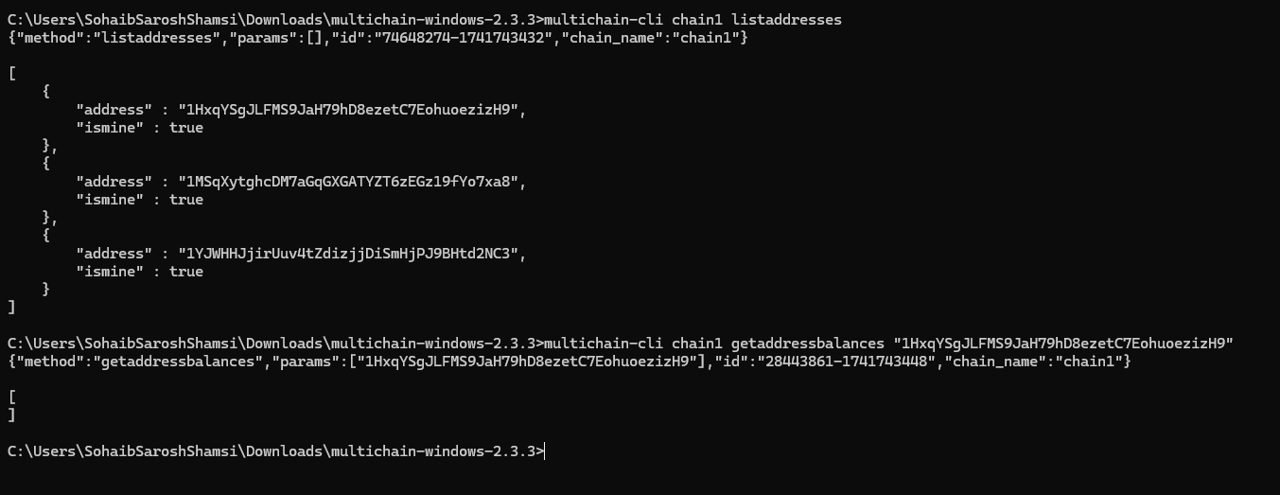
• address: The list of addresses associated with your node.
• permissions: Not directly available via listaddresses. You may need to use the grant command to manage permissions for each address.
• balance: The listaddresses command doesn’t show balance directly, but you can check it using getaddressbalances.
Q9.
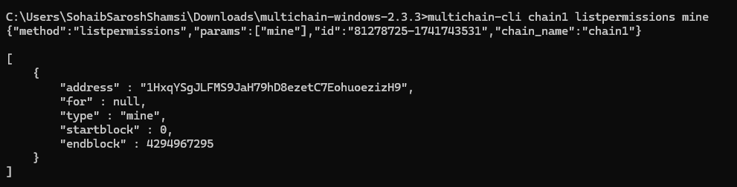
• Address: 1HxqYSgJLFMS9JaH79hD8ezetC7EohuoezizH9
• Permissions: mine — Permission to mine blocks.
• Pending: The permission is active and not pending.
• Startblock: The miner can start from block 0.
• Endblock: No expiration for the mining permission.

